CSE 310 L Data Warehousing and Mining

Date: 08-08-2023

1. Write a Python program to create a text file “transactions.txt” of the following from. Save the program as “create_textfile_static.py”

T1-A B C D

T2-B C D

T3-A B C

T4-B C E

T5-A C D

1. Write a Python program to read and display the contents of the file “transactions.txt”. Save the program as “read_textfile.py”
2. Write a Python program to create a text file “transaction2.txt”. Save the program as “create_textfile_dynamic.py”. Input should be in the following format. After executing the program 3, run program 2 and read the contents of the file “transactions2.txt”

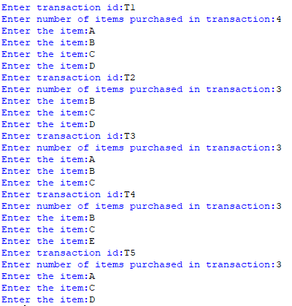

1. Write a python program to generate 100 random integers in the range 1 to 50 (including 1 and 50). Save the program as “random_number.py”)
2. Write a Python program to generate at least 10,000 transactions in a text file “transactions3.txt” with at least three items. Save the program as “experiment3.py”